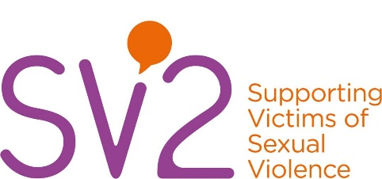

**Parent/Carer Evaluation Form**

Your feedback is important to us  
You can help us improve our services by completing this form.

1. What service(s) did/does your child access?

|  |
| --- |
| □ Therapy/Counselling for 0-17 yrs |
| □ ISVA (Independent Sexual Violence Advisor) under 17 yrs |

1. How easy was the referral process?

|  |
| --- |
| □ N/A |
| □ Very Easy |
| □ Easy |
| □ Difficult |
| □ Very Difficult |
| □ If Difficult/Very Difficult, please provide more information: …………………………………………………… |

1. Where was the appointment?

|  |
| --- |
| □ SV2 Ripley Office |
| □ SV2 Leopold Street Office |
| □ SV2 Buxton Office |
| □ Other please state: ……………………………………………… |

1. How did you find the environment your appointment took place in?

|  |
| --- |
| □ Accessible |
| □ Comfortable |
| □ Private |
| □ Welcoming |
| □ Easy to find |

1. Please rate how well the service met your childs needs (1 being not at all, 6 being completely)

1 2 3 4 5 6

1. Did your child’s SV2 worker… (tick all that apply)

|  |  |
| --- | --- |
| □ Contact you/your child when they said they would? | □ Attend appointments on time? |
| □ Help your child to understand how you have been affected? | □ Listen and understand your child’s needs? |
| □ Include you in planning your child’s support? | □ Meet the agreed expectations? |

1. What could have made the support better for your child?

………………………………………………………………………………………………………………………………………………………………………………………………………………………………………………………………………………………………………………………………………………………

1. If you, your child, or anyone else you know needed the support of SV2 in the future, would you return to or recommend the service based on the support you received?

|  |  |
| --- | --- |
| □ Yes | □ No |